
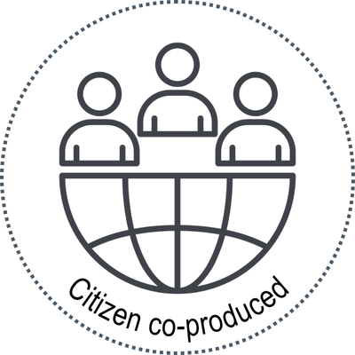
Citizen engagement request form
to be completed by evidence-synthesis teams

Principal researcher and evidence-synthesis team institution
Name:

Institution: | Email:
Contact person for citizen engagement
Name:

Institution: | Email:
About the evidence synthesis project
Topic:
Type of evidence synthesis document:
Requestor:
Funder: (if different than requestor)

Why is this evidence synthesis being conducted? Who will use the findings?
What is the timeline for citizen engagement specifically? (Start date, end date)
How will citizen engagement contribute to this project?
Are there specific requirements or experience that citizens who will be involved in this project should ideally bring?
At what step(s) to you foresee engaging with citizen partners?
☐ At the start – to review question, approach, outcomes
☐ At the analysis stage – to contribute to interpretation
☐ Towards the end – to review key messages
☐ At the plain language summary stage

What is the anticipated time commitment?
How will we work together?
☐ Virtual onboarding meeting (Zoom, Teams, etc.)
☐ What’sApp
☐ Email
☐ Telephone
☐ Dropbox link to the evidence synthesis document to provide your comments at your convenience during the feedback timeline period

Please submit the completed form to smitm105@mcmaster.ca with the subject line ‘Request for citizen engagement in evidence synthesis’.


 Copyright © 2025 McMaster University. This form was created by the McMaster Health Forum and is licensed under a Creative Commons Attribution-NonCommercial 4.0 International License.

