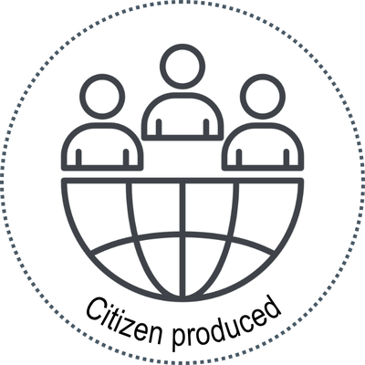


Title of evidence products
dd Month YYYY (Summary last updated on dd Month YYYY)
[MHF product code: ____]

Note: e.g. Protocol registered with PROSPERO (code with hyperlink) and published [journal]

[type of evidence product]
Plain language summary

What question did we want to answer?

[Insert the main question of the study here]

What are the key results?

Summarize the most relevant findings of the study in 3-4 declarative points
- Sub-points can be included when listing relevant items:
  - Item one
  - Item two

[insert key terms that would be necessary for someone unfamiliar with the topic to understand]
e.g.
Misinformation: Information that is false, inaccurate, or misleading according to the best available evidence at the time

Key Terms

- Sub-points can also be used if a declarative statement must be expanded upon (as a two-part statement)
  - These sub-points can help the reader understand the significance of a specific result, provided that the authors of the study have discussed it
- Include statements made by the authors about next steps (e.g. more research is needed on x)

Why was this done?

- Insert 3-4 points about the context/background of the study, the rationale behind why the study was conducted and the purpose of the study

How up to date is this?

[Insert any information about how up to date the study and included evidence is. Be sure to include information about when evidence was searched for, and any planned updates]

How did we do the research?

[Insert a sentence about how the study identified evidence, such as search criteria and inclusion]

[Insert a sentence about the methods used to synthesize the evidence]
e.g.
A database search was done which identified 2,086 articles. After review, 60 studies were included. The studies were not limited to any region and included a variety of approaches, but mostly experimental designs such as randomized controlled trials.

Studies were summarized and grouped to the ten responses/strategies to counter misinformation adapted from the Broadband Commission research report.

In thinking about the evidence, what else needs to be considered?

[Insert a statement from the main product about the currency, quality and local applicability]

This summary is based on a larger report that can be found at:

[hyperlink to McMaster Health Forum page for the corresponding evidence product]



Citation: This Plain Language Summary can be cited using the citation of the main product, which is: [use citation of the evidence product being summarized]
Citizen partner acknowledgement: We are thankful to our citizen partners (insert names if partners are willing to be acknowledged) for their contribution to the living evidence synthesis and drafting this plain-language summary of it. (customize depending on what the contribution was)
- This plain language summary was funded by [insert funder, funding statement]. The McMaster Health Forum receives both financial and in-kind support from McMaster University. The views expressed in the plain language summary are the views of the authors and should not be taken to represent the views of [funder] or McMaster University.

- *[any footnotes from asterisks used in citation or acknowledgement]
 This work is licensed under a Creative Commons Attribution-NonCommercial-NoDerivatives 4.0 International license.

